Contact Manager
Ideation Phase
Define the Problem Statements

Date | 16/02/2026
Team ID | 69a7c4fa7efb18082d5c308d
Project Name | Contact Manager
Maximum Marks | 2 Marks

Problem Statement

People struggle to effectively manage and maintain their growing professional and personal networks because existing solutions are either too complex, too expensive, or lack the simplicity needed for quick contact organization and retrieval.

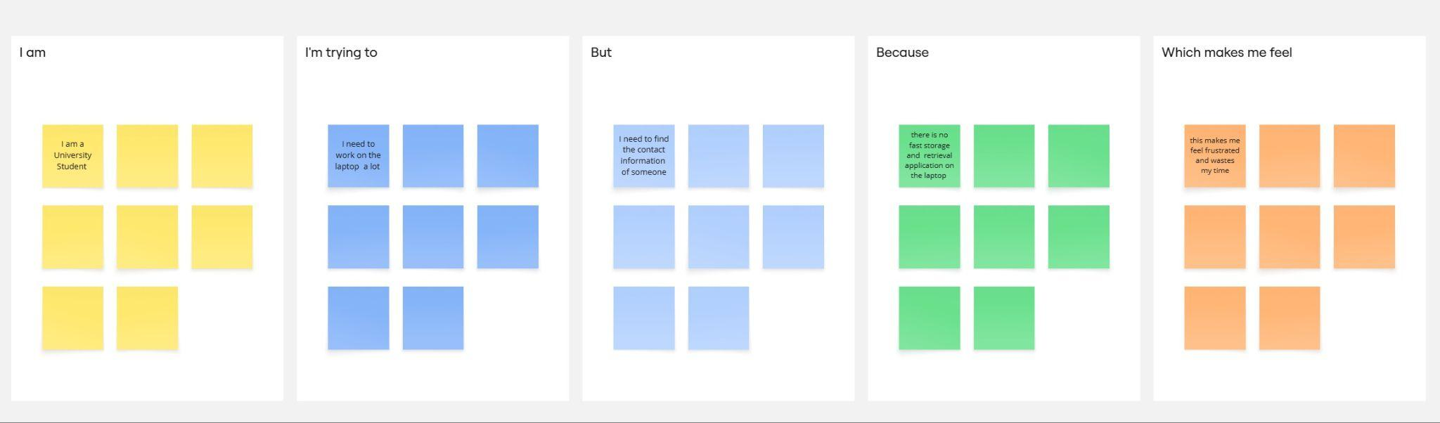

Problem Statement (PS) | I am (Customer) | I’m trying to | But | Because | Which makes me feel
PS-1 | A university student | Store and retrieve contacts on the laptop | Most platforms are only available for mobile phones | I need quick access to my contacts while i am working | Frustrated
PS-2 | A developer | Get the required contacts on laptop while working | The available applications are for mobile phone | I need a simple, visually appealing interface to store and get my contacts | Waste of time to continuously use mobile while working

